Digital Steganography
Ross Anderson

The final project I selected was steganography, with the end goal of being able to embed as much data as possible into an image without noticeable degradation of image quality.

To accomplish this, I choose to use ILUT to abstract the method away from having to encode and decode against a single image type. This abstraction would allow any image to be loaded. Any format that was lossless would work for the encoded image (I haven’t tested beyond PNG and BMP at this point). In addition, I used freeGLUT and ILUT to build a program that could display the noise floor of an image, and walk through each bit of each color to illustrate what happens to an image.

I was able to pack 10 bits of data into a single pixel with slight degradation. To reach 10 bits, I used 3 bits red, 3 bits green, and 4 bits of blue. On an 800x600 pixel image, that would allow for approximately 585KB of data to be packed in. Side by side, there is a slight detail that I could observe when viewing the images at full size. This became more apparent as more bits were packed into each image. The degradation I did observe came in two different areas. Parts of the picture appeared grainy, and there were some blue specs in unexpected areas. I believe the grainy appearance is the encoded data starting to show through. The blue specs seemed to show up more in the darker areas of the photo (black and gray). I suspect this is because the 4th bit of blue was enough to cause something that was black or near black to lose its appearance. (Refer to presentation and included files). One method that may help would be to encrypt the data prior to encoding. This would help to mask any patterns that could be caused by the ASCII character set, and would likely provide more random data. Another option would be to minimize the number of bits packed, and come up with what would amount to an encryption scheme to only use certain pixels (i.e. every 4th pixel). This obviously cuts down the amount of data that can be packed, but it could be spread across multiple images, or embedded in video.

Using the filter program I made, I also observed that the bit packing is highly dependent on the image. Using the included helo image, I walked through each bit and found the first 4 bits of red to be random, where only the first two bits of green and blue were. I was able to pack 4 bits in the red of that image without any issues.

As far as detection, using the filter program or something similar would be very obvious to see that data was there or some sort of manipulation was performed on the image. Using the filters, you can step through each bit of each color. The Least Significant Bit (LSB) has what appears to be streaks and indicate some sort of pattern is happening. But the transition between the last bit used to encode data, and the next bit with original image data shows significant changes (one has the repeating pattern, where the next will have the outline of the viewed image). Refer to included images below.
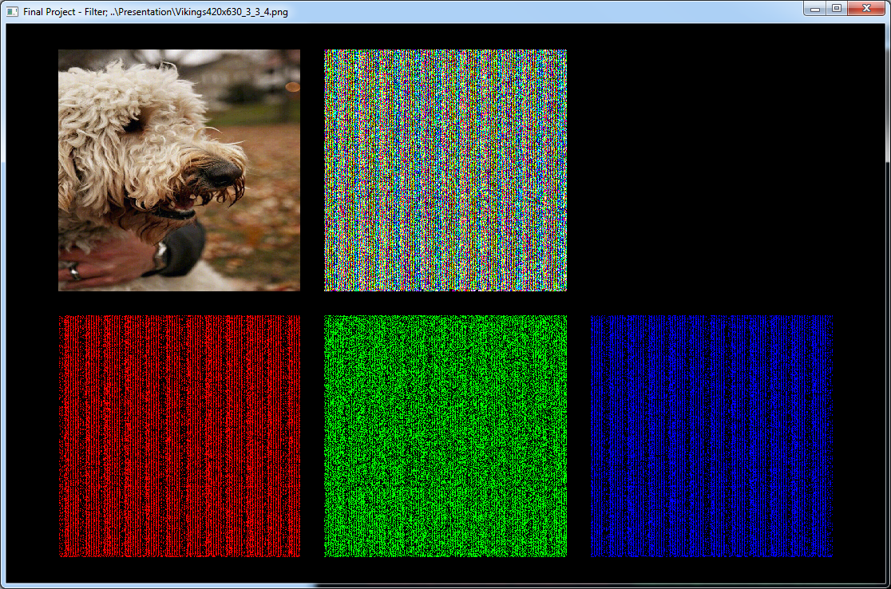
Viewing the 3rd bit of Red, 3rd Bit of Green and 4th bit of Blue

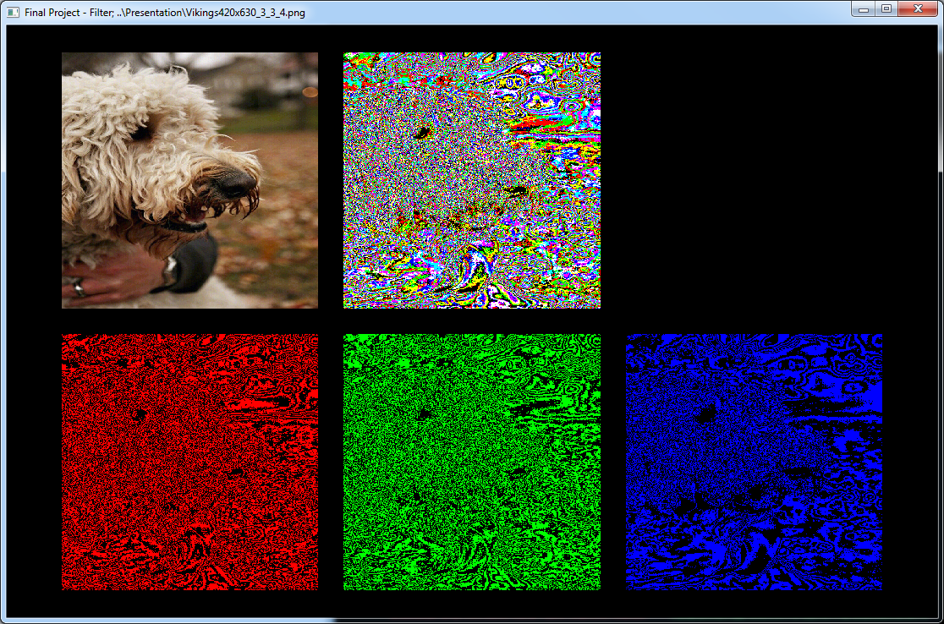
Viewing the 4th bit of Red, 4th bit of Green and 5th bit of Blue
In the course of building this, I discovered that the save features of ILUT weren’t very well documented, and didn’t seem to be widely used. It took a fair amount of trial and error to get the images to save, and then more trial and error to avoid having to manually invert the saved images for proper orientation (needed to set the origin of loaded files).

Digital steganography is actively being used. One recent case involved the 9 Russian spies arrested in the US in 2010. The FBI believes the spies were using Russian made software to encrypt and encode images with data and then transferring back to Russia (United States of America 9). Another recent case involved an individual linked to al-Qaeda carrying memory cards which appeared to contain pornography. Analysis indicated the videos actually contained over 100 documents including plots and training manuals (“al Qaeda”).

Although the encoded message is fairly easy to detect and once known it was there, would be easy to extract, addition of encryption would likely make it very difficult to detect, and most likely impossible to ever extract. In addition, while discussing with a co-worker, I also realized the filter program would be a great tool to use in detecting if any given image was photoshopped.

Sources
United States of America. United States of America v.
DEFENDANT # 1 , a/k/a "Christopher R. Metsos,"
DEFENDANT # 2, a/k/a "Richard Murphy,"
DEFENDANT # 3, a/k/a "Cynthia Murphy,"
DEFENDANT # 4, a/k/a "Donald Howard Heathfield,
DEFENDANT # 5, a/k/a "Tracey Lee Ann Foley,"
DEFENDANT # 6, a/k/a "Michael Zottoli,"
DEFENDANT # 7, a/k/a "Patricia Mills,"
DEFENDANT # 8, a/k/a "Juan Lazaro," and
VICK PELAEZ. 2010. Department of Justice <http://www.justice.gov/opa/documents/062810complaint2.pdf>.

“Documents reveal al Qaeda's plans for seizing cruise ships, carnage in Europe.” CNN 30 Apr. 2012. <http://www.cnn.com/2012/04/30/world/al-qaeda-documents-future/index.html?hpt=hp_t2>.

